**Adding an existing project to GitHub using the command line :**

1. Open git bash in project directory :

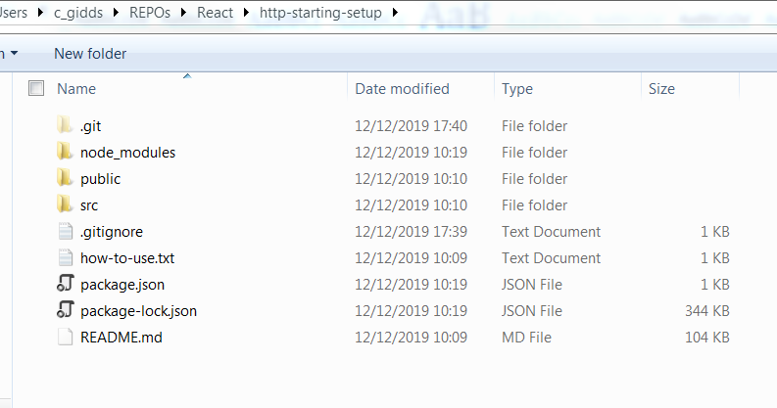

1. Git init
2. To ignore the node modules push
   1. Create .gitignorefile through cmd   
       🡺 touch .gitignore
   2. Open and add /node_modules in file

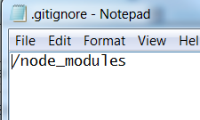

1. Git add .
2. git commit -m "initial commit"
3. git remote add origin https://github.com/sgidd/http-starting-setup.git
4. git remote -v
5. git push -f origin master